***Problem 8: Albu Maria-Ioana group 911***

1. I have chosen the function f(x) = x2, as it is convex. The minimum value of this function is 0, so to show that the function converges to 0, I have picked η = 0.02.

* Note: In points a) and b) of the exercise, the indexes of x are i = {1, 5, 10, 15, 20, 50, 120} and in all the exercises the first term (x0) is always 10.
* The printed list in every point is the one with the calculated values of xi, using the mentioned indexes and value of η.

Output:

1. Using the same function f(x) = x2, I chose an η = 0.1, which is bigger than 0.01.

We can still observe that the function converges to 0, but this time, the terms approach 0 much faster than when the learning rate was 0.01.

Output:

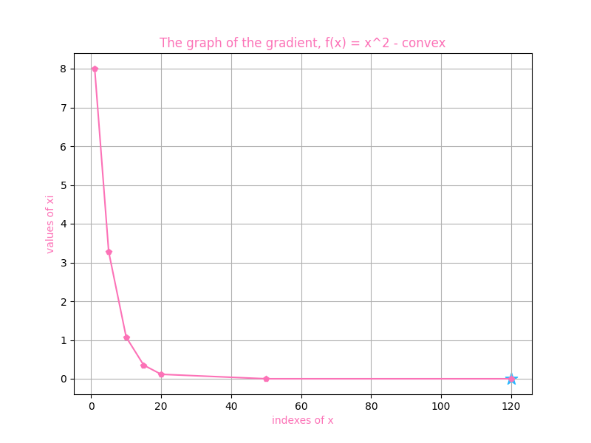

The last term may be hard to visualize due to the way Python writes it (as the value is very small due to the index 120 being sort of large) but using the graph we can see that it is also extremely close to 0. So, we can observe that the function converges to 0 once again.

1. To show that by picking an η too large this method can lead to the divergence of the method, I have chosen η = 1.02.



I have changed the index values to better show the way the function diverges as the indexes get bigger and bigger. The blue star is also still positioned at 0, as that is the minimum value of f, to show that it gets further away from that value with each calculated xi.

Output:

1. I have chosen my non-convex function f(x) = x3. The function is concave for x in range (-∞, 0] and convex for x in range [0, ∞). So, the local minimum is 0. The indexes are now: i = {10, 50, 120, 150, 300, 1000, 1500}, to show that even by taking much greater indexes than in the previous points, the values only get smaller and smaller due to the way the gradient descent method works.



Output:

